**RAMANUJAN COLLEGE**

(University of Delhi)

**COMPUTER NETWORK**

**(CISCO PACKET TRACER)**

**(PRACTICAL)**

|  |  |  |
| --- | --- | --- |
| **Name :** | Devansh Tyagi |  |
| **Roll No. :** | 20221416 |  |
| **Course :** | B.Sc. (Hons.) Computer Science |  |
| **Year :** | Second |  |

1. **To study and perform PC to PC communication.**

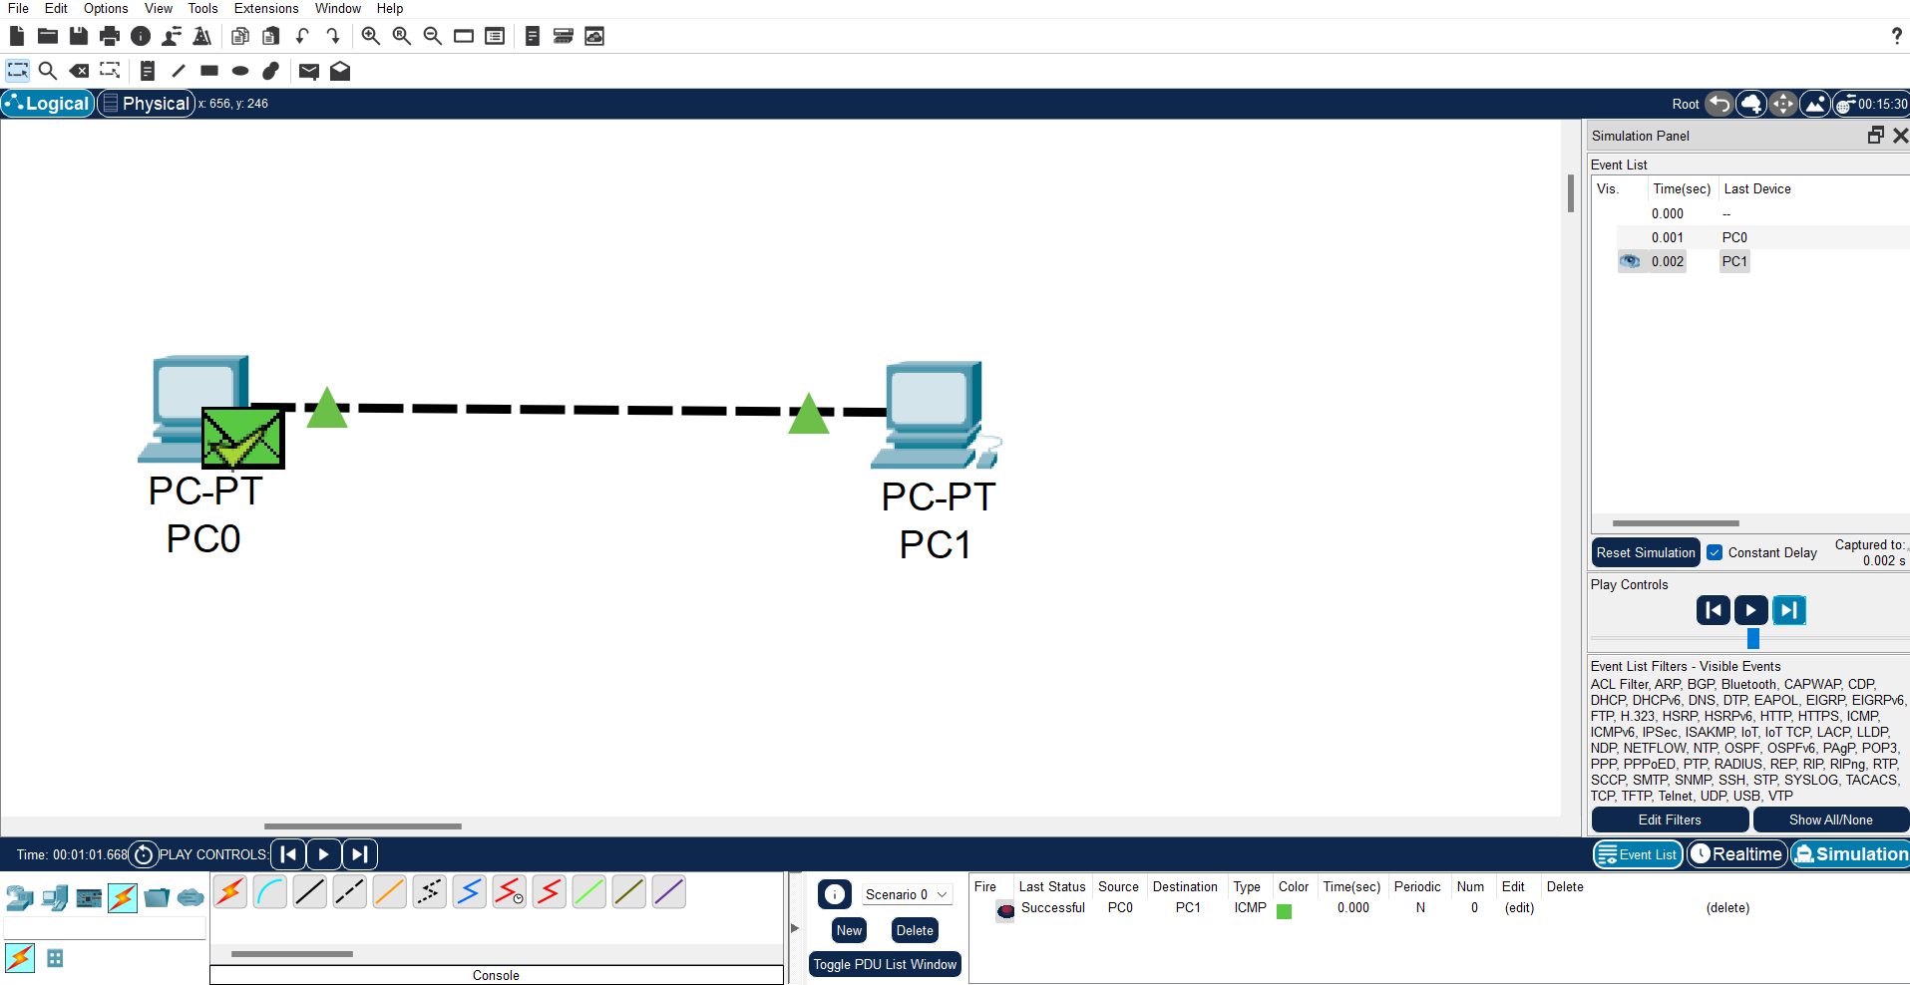

**Steps:**

1. ***Open Cisco Packet Tracer:*** Launch the Cisco Packet Tracer application on your computer.
2. ***Create Network Topology:*** Start a new project and drag two PCs from the "End Devices" section onto the workspace.
3. ***Connect PCs Directly:*** There's no need for a switch when you have only two PCs. Use a straight-through copper cable to connect one PC's Ethernet port to the other PC's Ethernet port. Simply click and drag from one PC's Ethernet port to the other's to create the connection.
4. ***Assign IP Addresses:*** Double-click on each PC to open its configuration window. Go to the "Desktop" tab and select "IP Configuration." Assign IP addresses to each PC in the same subnet. For example, you can use 192.168.1.1 for PC1 and 192.168.1.2 for PC2, both with a subnet mask of 255.255.255.0.
5. ***Verify Connectivity:*** Open the command prompt on each PC. You can do this by clicking on the "Command Prompt" icon from the desktop. Then, use the ping command followed by the IP address of the other PC to verify connectivity. For instance, on PC1, type ping 192.168.1.2 and press Enter. You should see replies indicating successful communication.
6. ***Perform PC-to-PC Communication:*** Now that the PCs are connected and configured, you can send messages or files between them. You can use any software installed on the PCs for this purpose, such as messaging apps or file-sharing tools.

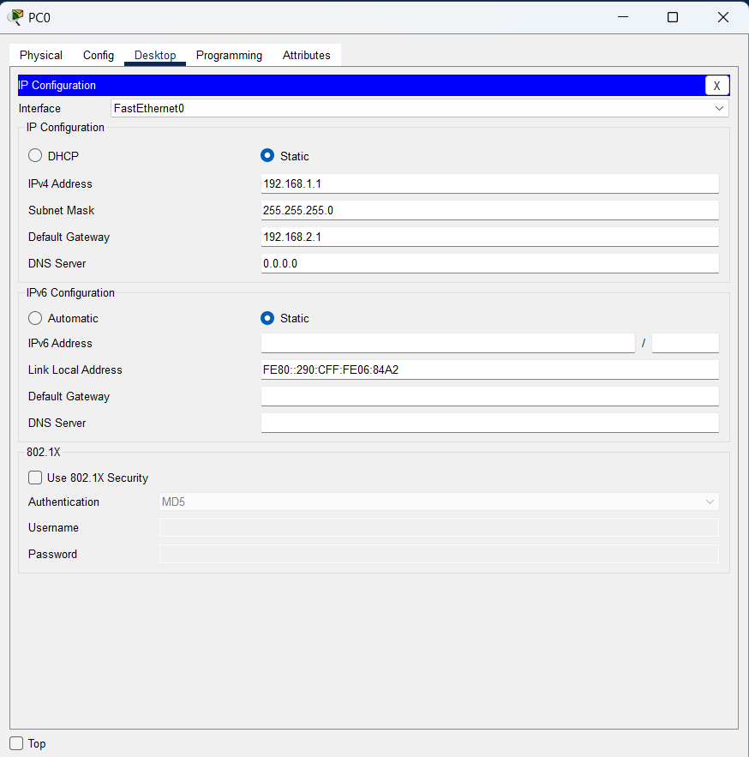 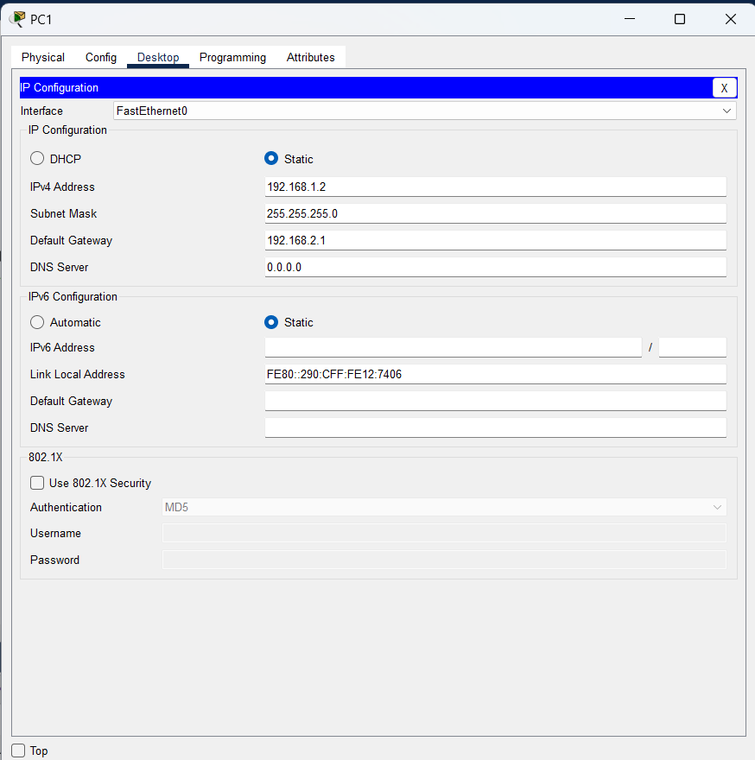

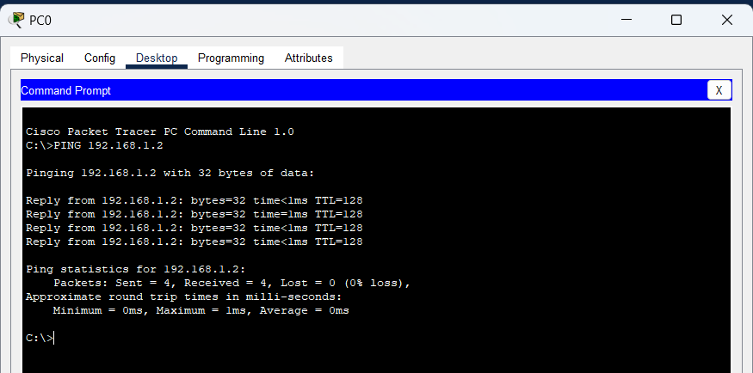

1. **To create Star topology using Hub and Switch.**

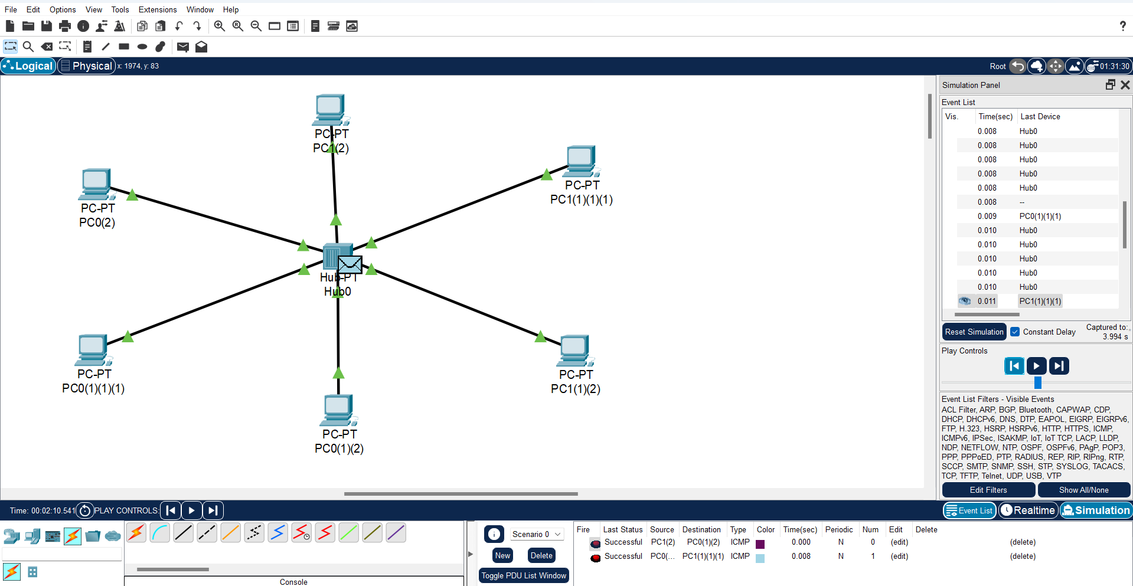

**Steps using Hub:**

1. ***Launch Cisco Packet Tracer:***Open the Cisco Packet Tracer application on your computer.
2. ***Create Network Topology:***Start a new project by selecting "Empty Physical Workspace". Then, drag and drop a Hub from the "Hub/Switches" section onto the workspace.
3. ***Connect Devices to the Hub:***Drag and drop multiple PCs from the "End Devices" section onto the workspace. Use straight-through copper cables to connect each PC's Ethernet port to an available port on the Hub.
4. ***Assign IP Addresses (Optional):***If you want to configure IP addresses for the PCs, double-click on each PC to open its configuration window. Navigate to the "Desktop" tab and select "IP Configuration". Assign IP addresses to each PC in the same subnet.
5. ***Verify Connectivity:***Open the command prompt on each PC by clicking on the "Command Prompt" icon from the desktop. Use the ping command followed by the IP address of another PC to verify connectivity. For example, on PC1, type ping [IP address of PC2] and press Enter. You should receive replies indicating successful communication.
6. ***Observe Hub Operation:***Unlike switches, hubs operate at the physical layer of the OSI model and simply broadcast incoming data to all connected devices. You can observe this behavior by sending messages between PCs and observing how the hub forwards the data to all connected devices.

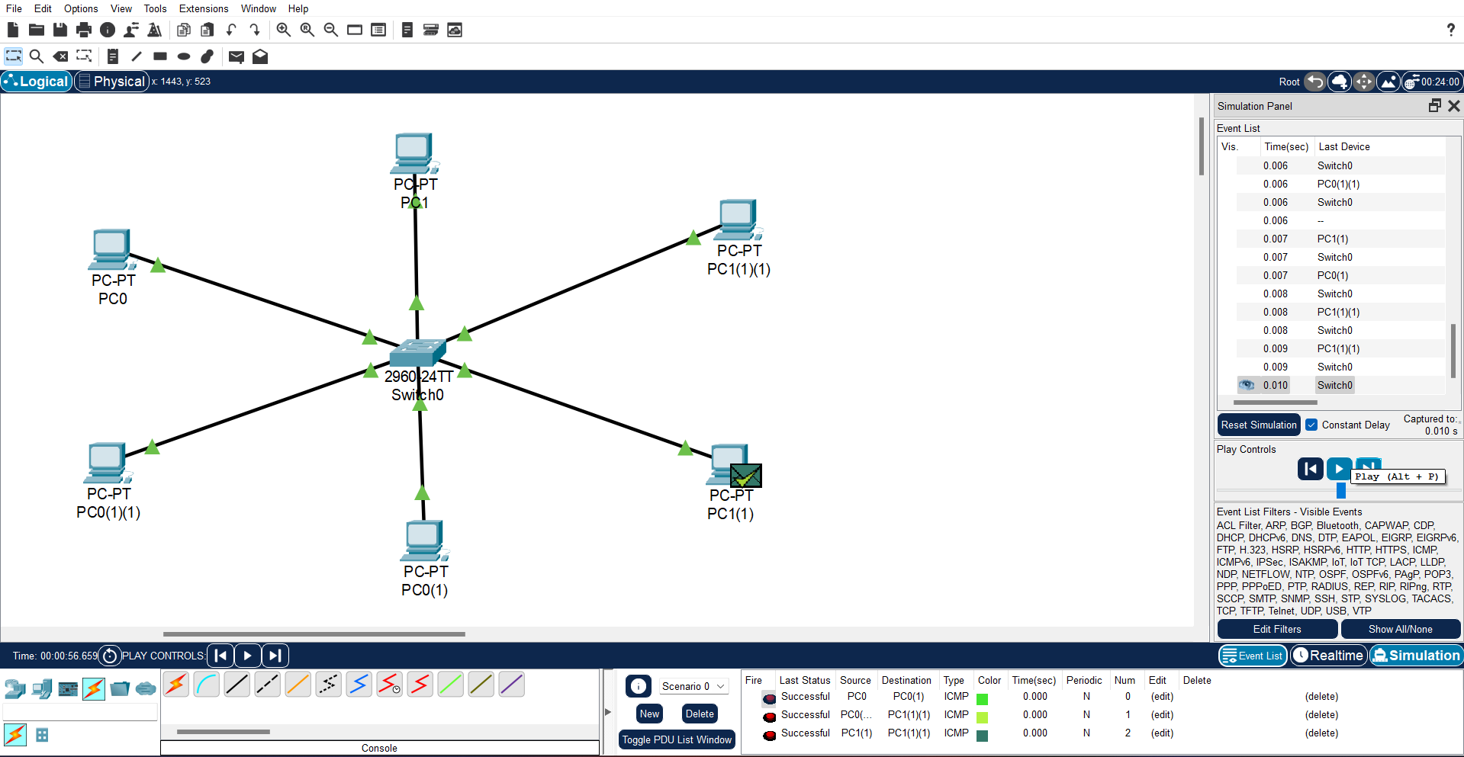

**Steps using Switch:**

1. ***Launch Cisco Packet Tracer****:* Open the Cisco Packet Tracer application on your computer.
2. ***Create Network Topology****:* Start a new project by selecting "Empty Physical Workspace". Then, drag and drop a Switch from the "Switches" section onto the workspace.
3. ***Connect Devices to the Switch****:* Drag and drop multiple PCs from the "End Devices" section onto the workspace. Use straight-through copper cables to connect each PC's Ethernet port to an available port on the Switch.
4. ***Assign IP Addresses (Optional)****:* If you want to configure IP addresses for the PCs, double-click on each PC to open its configuration window. Navigate to the "Desktop" tab and select "IP Configuration". Assign IP addresses to each PC in the same subnet.
5. ***Verify Connectivity****:* Open the command prompt on each PC by clicking on the "Command Prompt" icon from the desktop. Use the ping command followed by the IP address of another PC to verify connectivity. For example, on PC1, type ping [IP address of PC2] and press Enter. You should receive replies indicating successful communication.
6. ***Observe Switch Operation****:* Unlike hubs, switches operate at the data link layer of the OSI model and maintain a MAC address table to forward data only to the intended recipient. You can observe this behavior by sending messages between PCs and observing how the switch efficiently forwards the data only to the intended recipient.

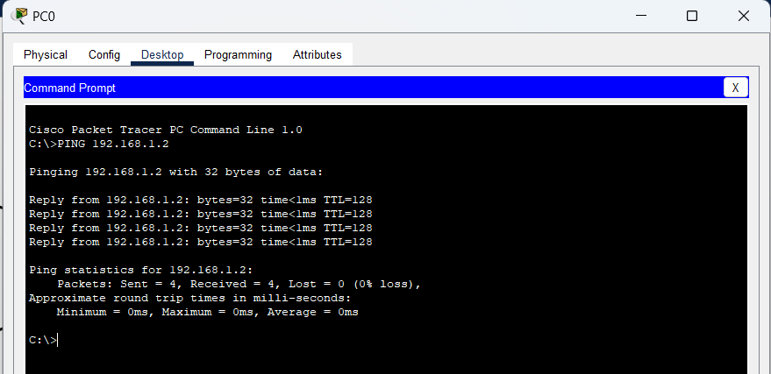

 

1. **To create Bus, Ring, Tree, Hybrid, Mesh topologies.**

* **Bus Topology**

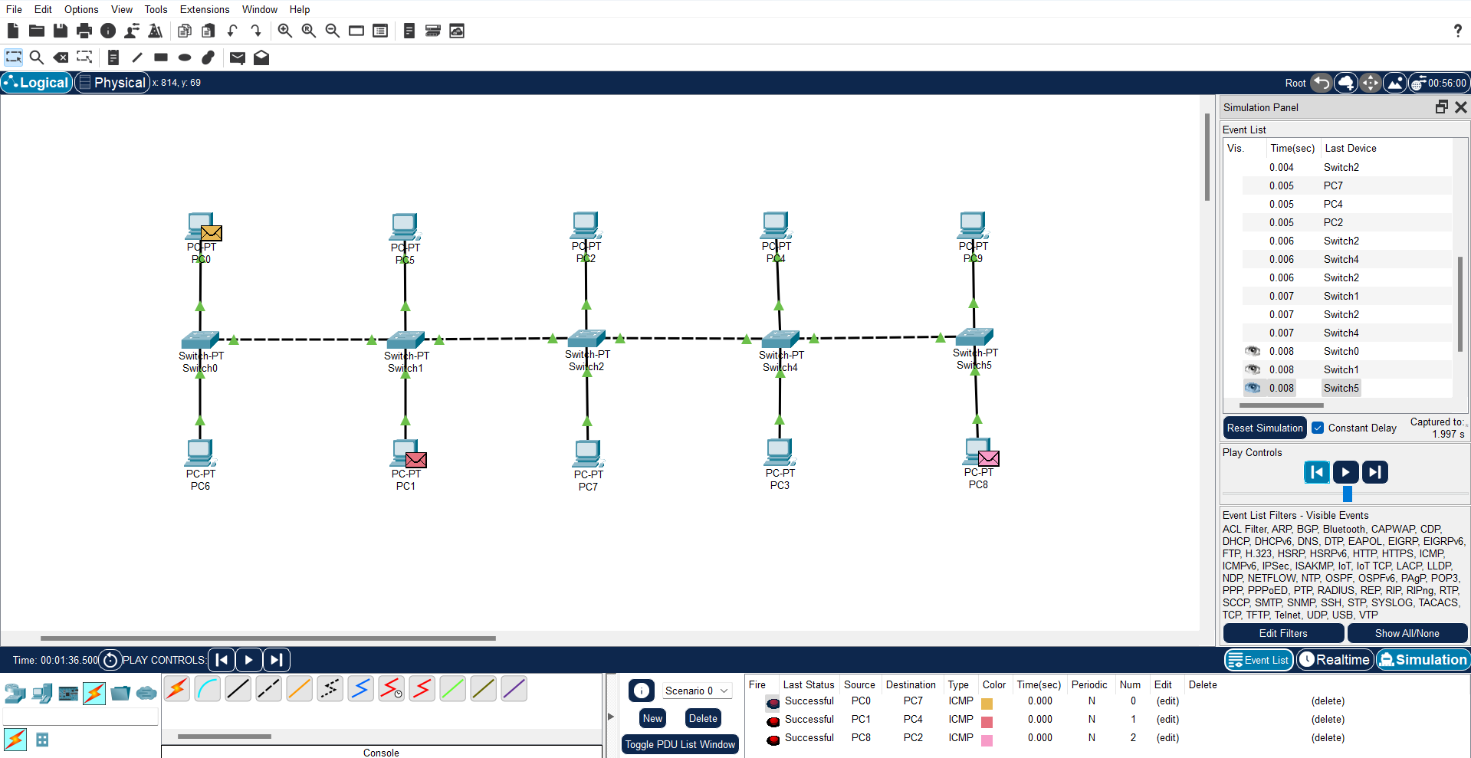

**Steps:**

1. ***Launch Cisco Packet Tracer:*** Open the Cisco Packet Tracer application on your computer.
2. ***Create Network Topology:*** Start a new project by selecting "Empty Physical Workspace". Then, drag and drop a Switch from the "Switches" section onto the workspace.
3. ***Connect Devices to the Switch:*** Drag and drop multiple PCs from the "End Devices" section onto the workspace. Use straight-through copper cables to connect each PC's Ethernet port to an available port on the Switch.
4. ***Assign IP Addresses (Optional):*** If you want to configure IP addresses for the PCs, double-click on each PC to open its configuration window. Navigate to the "Desktop" tab and select "IP Configuration". Assign IP addresses to each PC in the same subnet.
5. ***Verify Connectivity:*** Open the command prompt on each PC by clicking on the "Command Prompt" icon from the desktop. Use the ping command followed by the IP address of another PC to verify connectivity. For example, on PC1, type ping [IP address of PC2] and press Enter. You should receive replies indicating successful communication.
6. ***Observe Bus Topology:*** In a Bus topology, all devices are connected to a single shared communication medium. In Packet Tracer, the Switch acts as this shared medium. You can observe the communication by sending messages between PCs and observing how the Switch forwards the data to the intended recipient.

* **Ring Topology**

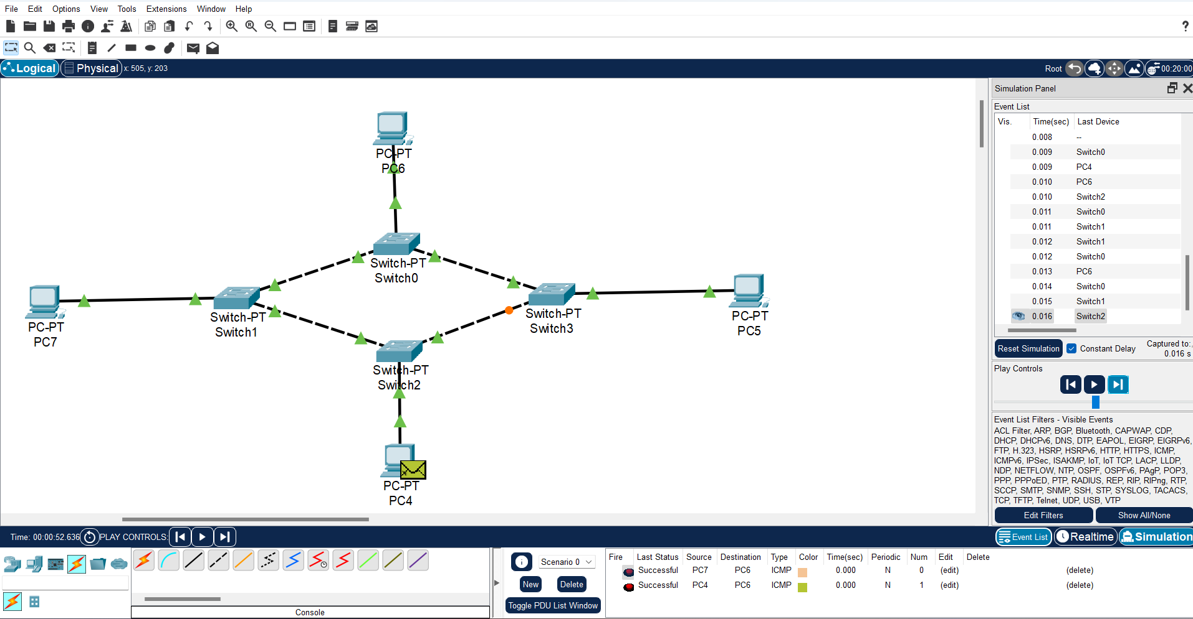

**Steps:**

1. ***Launch Cisco Packet Tracer:*** Open the Cisco Packet Tracer application on your computer.
2. ***Create Network Topology:*** Start a new project by selecting "Empty Physical Workspace". Then, drag and drop multiple PCs or other end devices from the "End Devices" section onto the workspace.
3. ***Connect Devices in a Ring:*** Connect the devices in a circular manner so that each device is connected to exactly two other devices, forming a closed loop. You can use straight-through copper cables to make these connections.
4. ***Assign IP Addresses (Optional):*** If you want to configure IP addresses for the devices, double-click on each device to open its configuration window. Navigate to the "Desktop" tab and select "IP Configuration". Assign IP addresses to each device in the same subnet.
5. ***Verify Connectivity:*** Open the command prompt or terminal on each device and use the ping command followed by the IP address of another device to verify connectivity. For example, on PC1, type ping [IP address of PC2] and press Enter. You should receive replies indicating successful communication.
6. ***Observe Ring Topology Operation:*** In a Ring topology, data travels in one direction around the ring until it reaches its destination. You can observe this behavior by sending messages between devices and observing how the data flows around the ring.

* **Tree Topology**

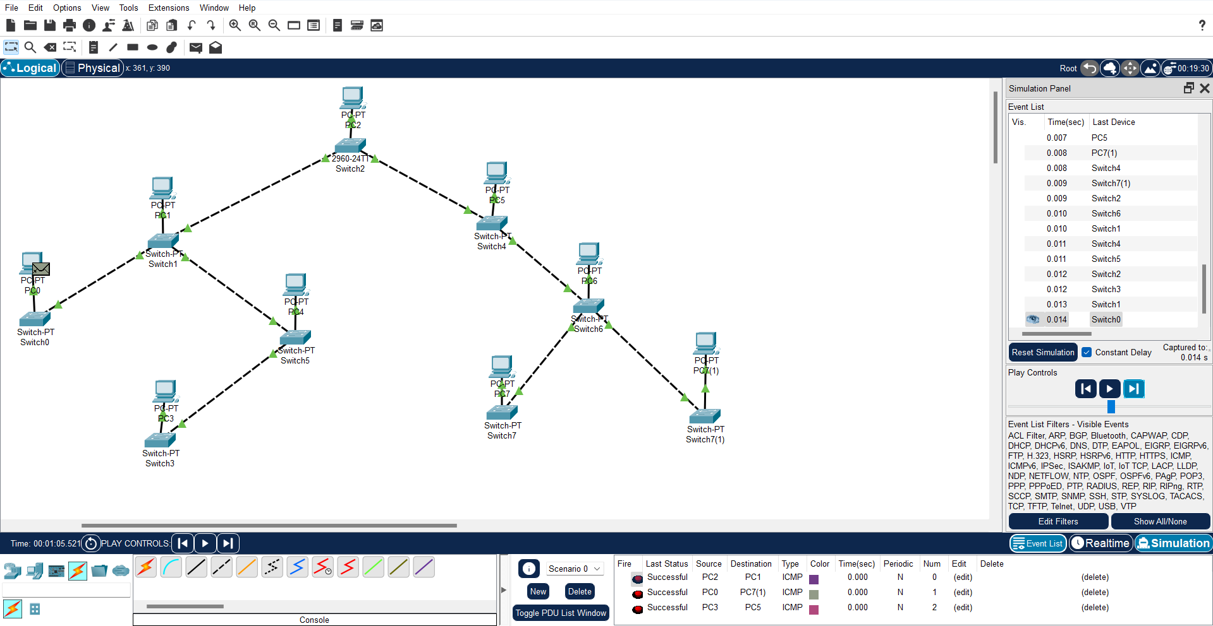

**Steps:**

1. ***Launch Cisco Packet Tracer:*** Open the Cisco Packet Tracer application on your computer.
2. ***Create Network Topology:*** Start a new project by selecting "Empty Physical Workspace". Then, drag and drop a Router from the "Routers" section onto the workspace.
3. ***Connect Devices Hierarchically:*** Connect multiple switches to the router. Each switch represents a level in the hierarchy. For example, you can connect three switches directly to the router to represent three branches.
4. ***Connect End Devices to Switches:*** Connect end devices (such as PCs or laptops) to each switch. These devices will be the leaves of the tree, representing the endpoints of the network.
5. ***Assign IP Addresses (Optional):*** If you want to configure IP addresses for the devices, double-click on each device to open its configuration window. Navigate to the "Desktop" tab and select "IP Configuration". Assign IP addresses to each device in the same subnet.
6. ***Verify Connectivity:*** Open the command prompt or terminal on each device and use the ping command followed by the IP address of another device to verify connectivity. For example, on PC1, type ping [IP address of PC2] and press Enter. You should receive replies indicating successful communication.
7. ***Observe Tree Topology Operation:*** In a Tree topology, data flows from the leaves towards the root (router). You can observe this behavior by sending messages between devices and observing how the data flows through the switches towards the central router.

* **Hybrid Topology**

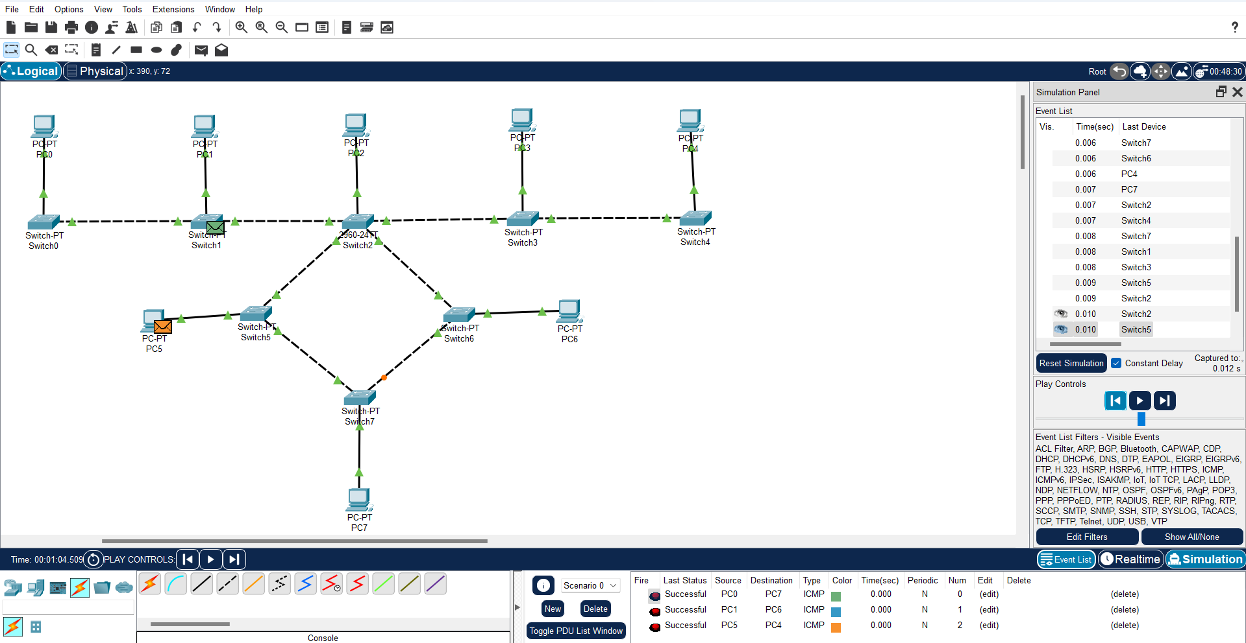

**Steps:**

1. ***Launch Cisco Packet Tracer:*** Open the Cisco Packet Tracer application on your computer.
2. ***Plan Your Hybrid Topology:*** Decide which types of network topologies you want to combine and how you want to interconnect them. For example, you might want to have a main Star topology with additional Bus or Ring topologies branching off from it.
3. ***Create Main Topology:*** Start by creating your main topology. This could be a Star topology with a Switch at the center and multiple PCs connected to it.
4. ***Add Additional Topologies:*** Once you have your main topology set up, add additional topologies as needed. For example, you could add a Bus topology by connecting a few PCs directly to each other using straight-through copper cables.
5. ***Interconnect Topologies:*** Use routers, switches, or even end devices to interconnect the different topologies. For instance, you could connect the main Star topology to the Bus or Ring topology using a router or a switch.
6. ***Assign IP Addresses (Optional):*** If you want to configure IP addresses for the devices, double-click on each device to open its configuration window. Navigate to the "Desktop" tab and select "IP Configuration". Assign IP addresses to each device in the same subnet.
7. ***Verify Connectivity:*** Open the command prompt or terminal on each device and use the ping command followed by the IP address of another device to verify connectivity. For example, on PC1, type ping [IP address of PC2] and press Enter. You should receive replies indicating successful communication.
8. ***Observe Hybrid Topology Operation:*** Test the communication between devices in different parts of the network and observe how data flows through the various interconnected topologies.

* **Mesh Topology**

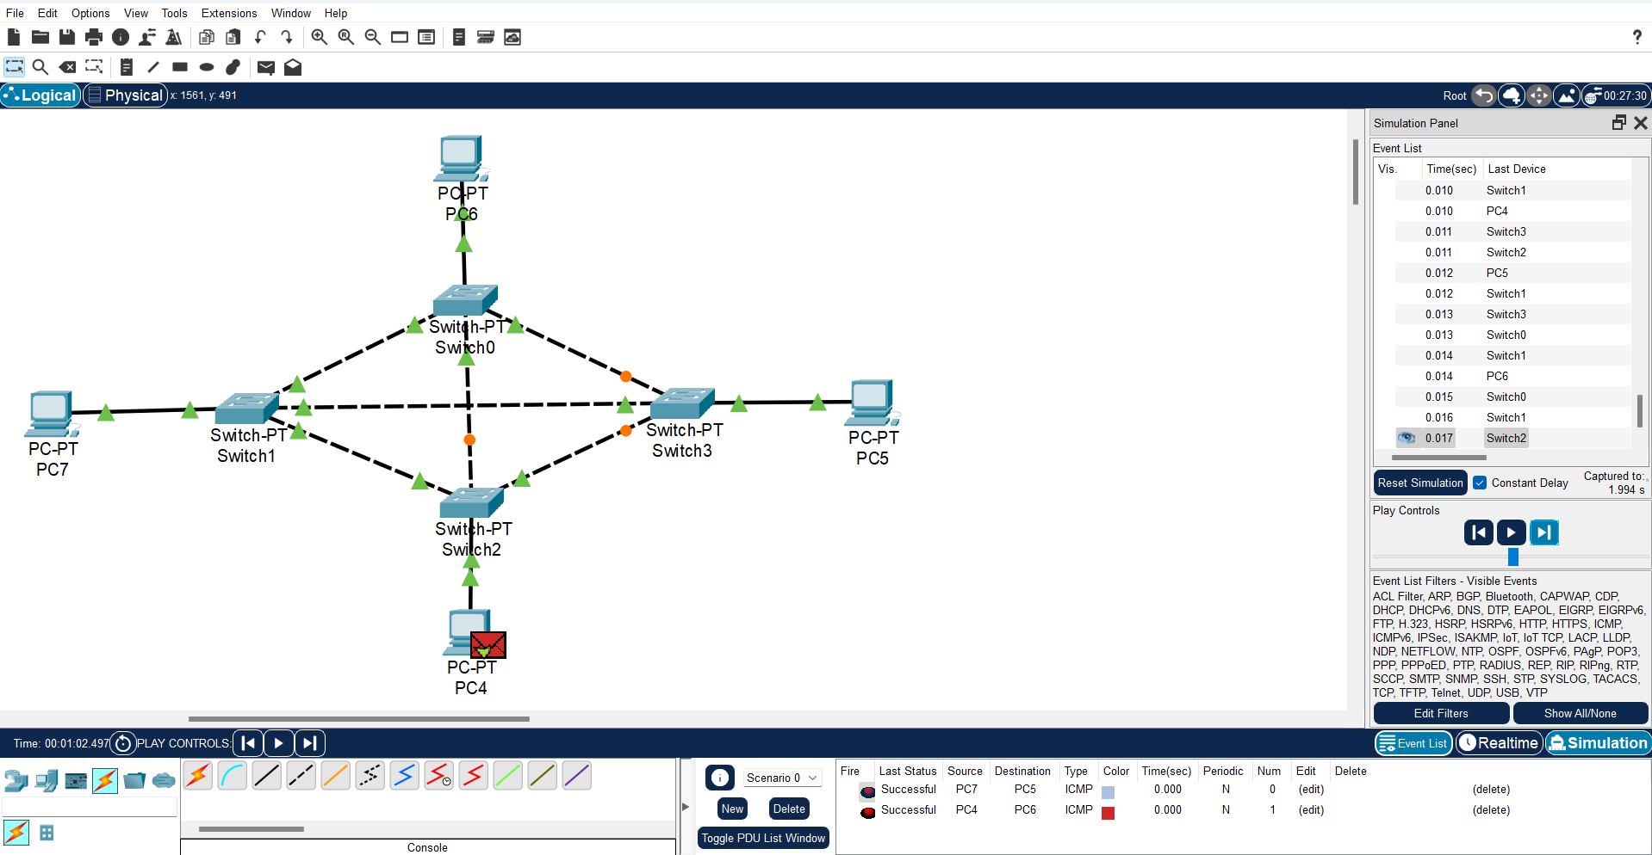

**Steps:**

1. ***Launch Cisco Packet Tracer:*** Open the Cisco Packet Tracer application on your computer.
2. ***Create Network Topology:*** Start a new project by selecting "Empty Physical Workspace". Then, drag and drop multiple end devices (such as PCs or laptops) onto the workspace.
3. ***Connect Devices:*** Connect each device to every other device in the network. This means creating a direct connection between each pair of devices. Use straight-through copper cables or any appropriate cable type depending on the devices you're connecting.
4. ***Assign IP Addresses (Optional):*** Double-click on each device to open its configuration window. Navigate to the "Desktop" tab and select "IP Configuration". Assign IP addresses to each device. Since this is a mesh topology, each device should have a unique IP address within the same subnet.
5. ***Verify Connectivity:*** Open the command prompt or terminal on each device and use the ping command followed by the IP address of another device to verify connectivity. For example, on PC1, type ping [IP address of PC2] and press Enter. You should receive replies indicating successful communication.
6. ***Observe Mesh Topology Operation:*** In a mesh topology, devices are interconnected redundantly, providing multiple paths for data to travel. You can observe this redundancy by sending messages between devices and observing how data can reach its destination through multiple paths.
7. **Perform an initial Switch configuration.**

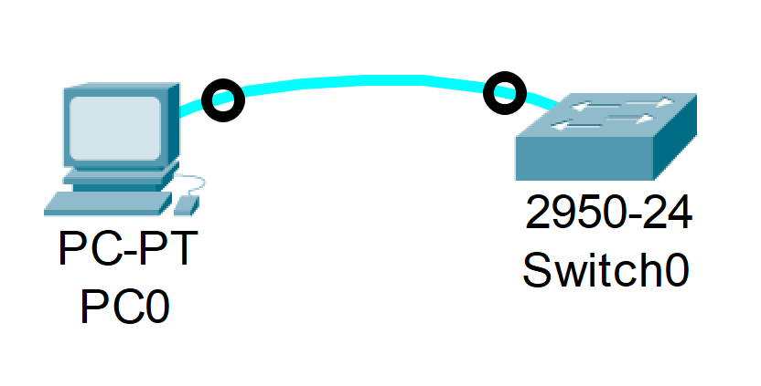

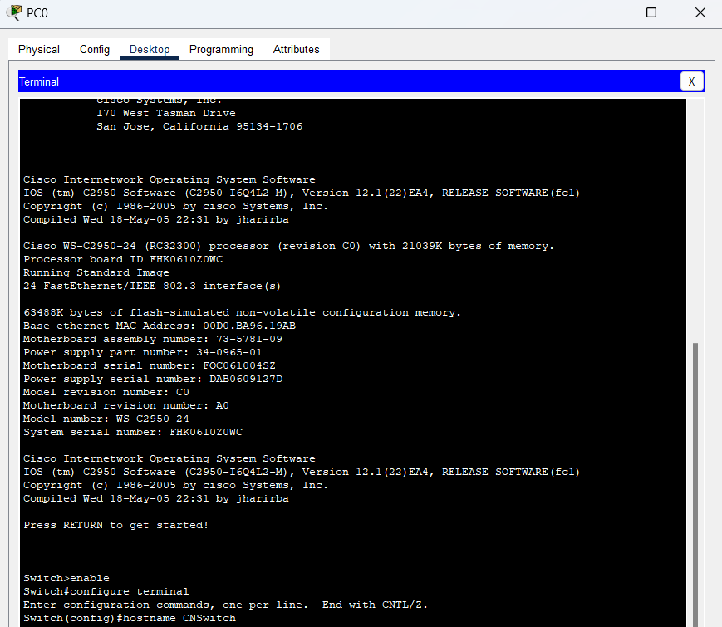

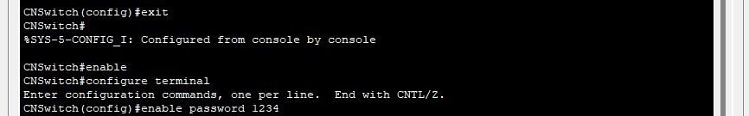

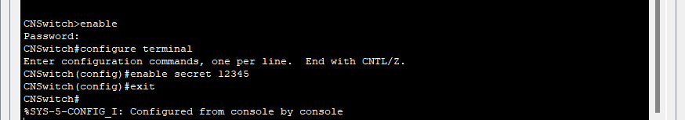

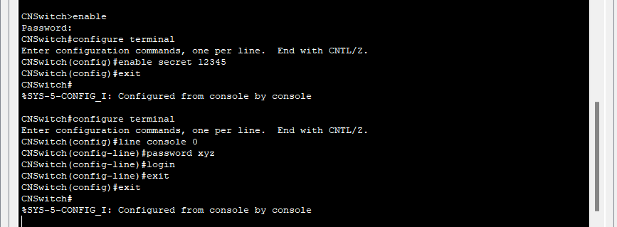

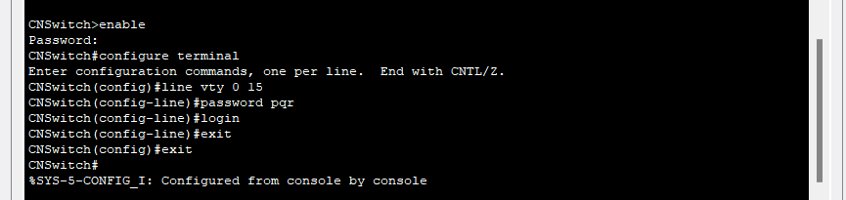

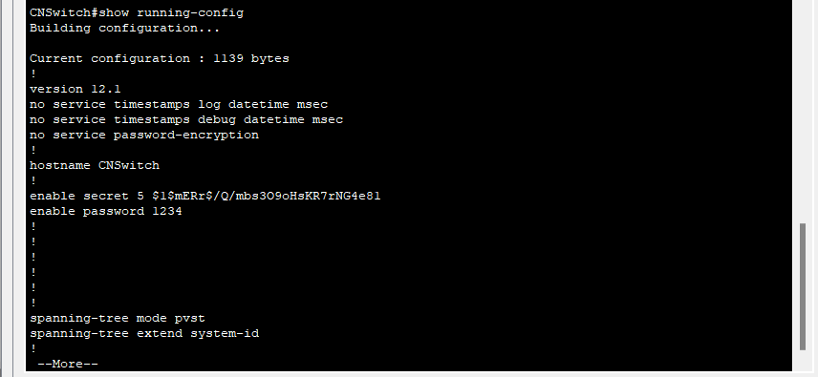

1. **Perform an initial Router configuration.**

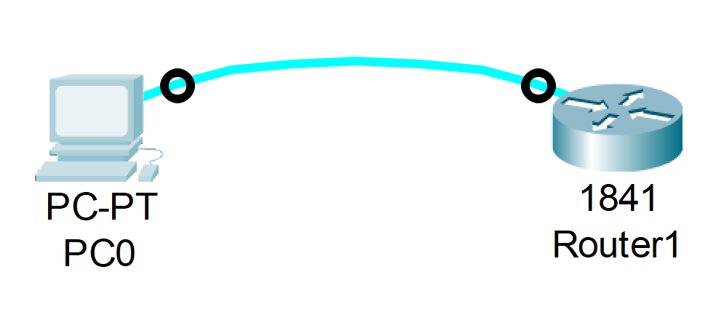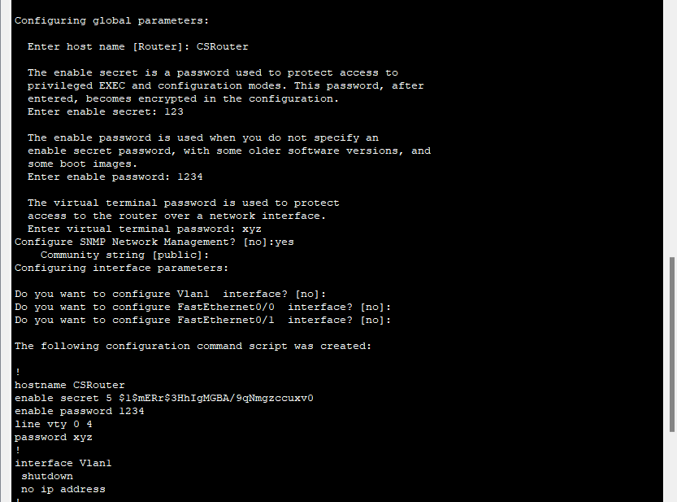 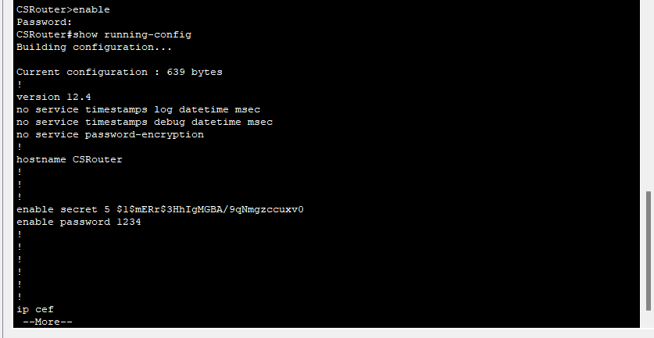

1. **To implement Client Server Network.**

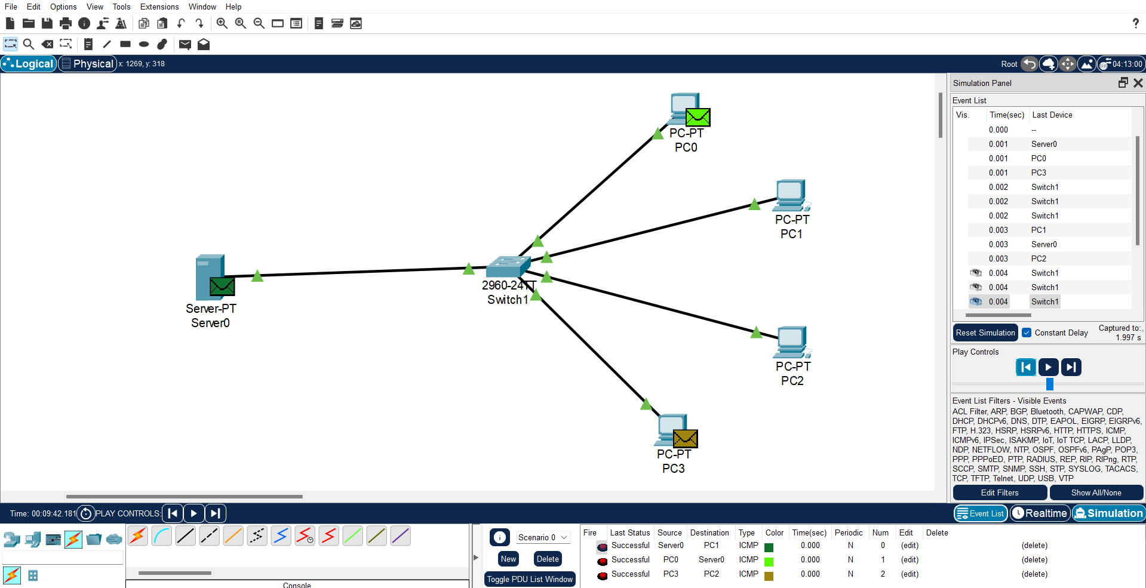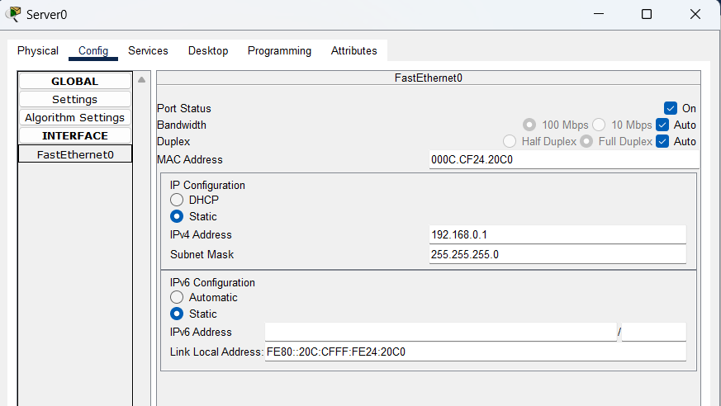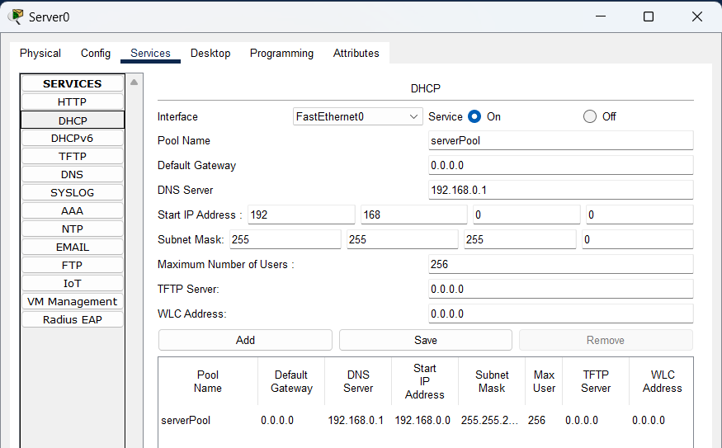 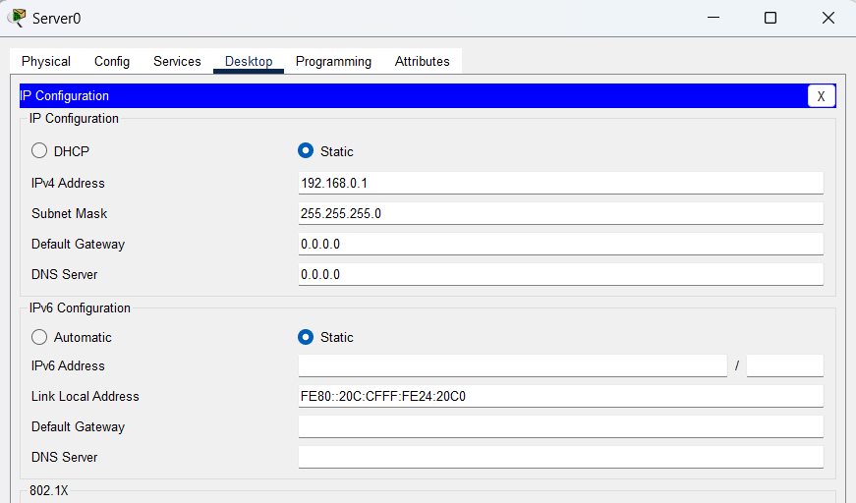 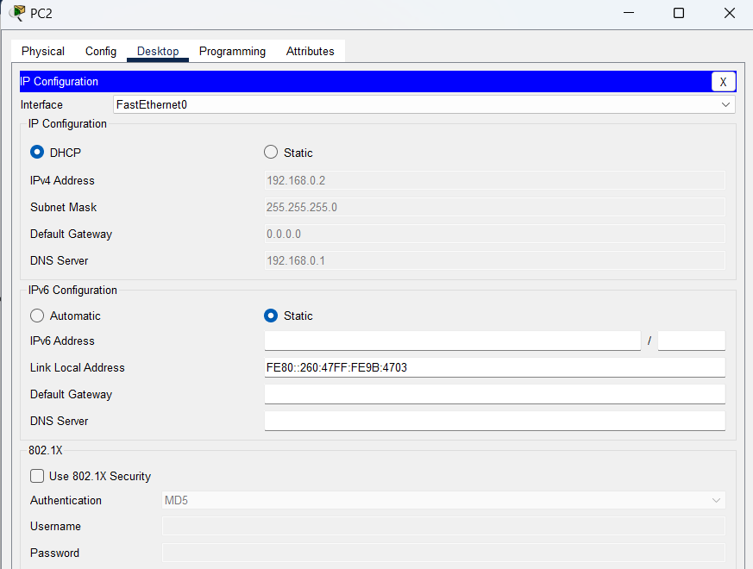

**Steps:**

1. ***Launch Cisco Packet Tracer****:* Open the Cisco Packet Tracer application on your computer.
2. ***Create Network Topology****:* Start a new project by selecting "Empty Physical Workspace". Then, drag and drop the necessary devices onto the workspace. You'll need at least one server device and one or more client devices.
3. ***Select Server Device****:* Choose a device to act as the server. This could be a PC or a server device from the "End Devices" section. Drag and drop it onto the workspace.
4. ***Select Client Devices****:* Choose one or more devices to act as clients. These could be PCs or laptops from the "End Devices" section. Drag and drop them onto the workspace.
5. ***Connect Devices****:* Use appropriate cables to connect the client devices to the server device. For wired connections, use Ethernet cables. For wireless connections, configure the devices accordingly.
6. ***Configure Server Services (Optional)****:* Double-click on the server device to open its configuration window. If necessary, configure the server's operating system to provide the desired services. This could include setting up file sharing, web hosting, database services, etc.
7. ***Assign IP Addresses (Optional)****:* Double-click on each device to open its configuration window. Navigate to the "Desktop" tab and select "IP Configuration". Assign IP addresses to each device in the same subnet. This step is optional but can help in managing the network and ensuring proper communication.
8. ***Verify Connectivity****:* Open the command prompt or terminal on each device and use the ping command followed by the IP address of another device to verify connectivity. For example, on a client device, type ping [IP address of the server] and press Enter. You should receive replies indicating successful communication.
9. ***Access Server Resources****:* On the client devices, you can now access the resources or services provided by the server. This could include accessing shared files, websites hosted on the server, databases, etc.
10. ***Test Communication****:* Perform various tasks on the client devices that require interaction with the server. This could involve accessing files, browsing websites, or querying databases.
11. ***Monitor Network Traffic (Optional)****:* You can use Packet Tracer's simulation mode to monitor network traffic and analyze how data flows between the client and server devices.
12. **To implement connection between devices using router.**

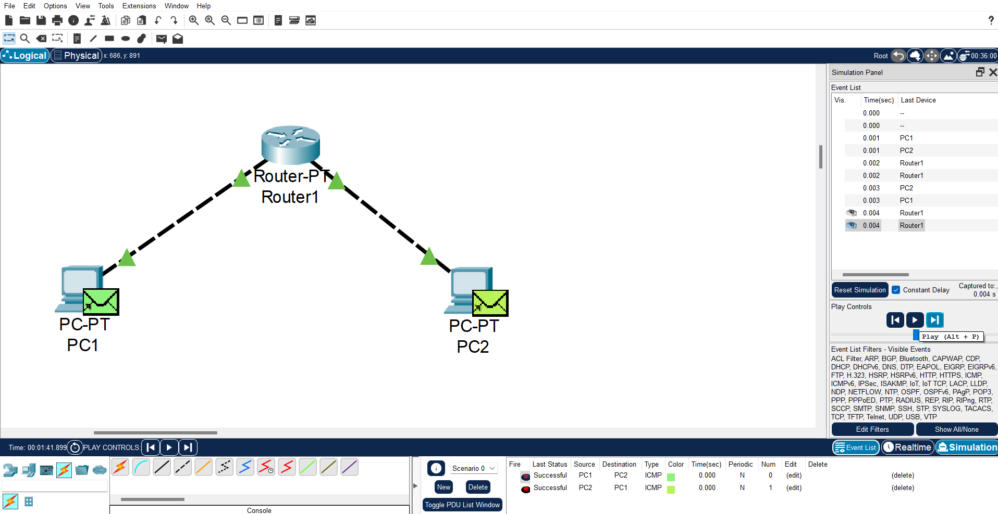

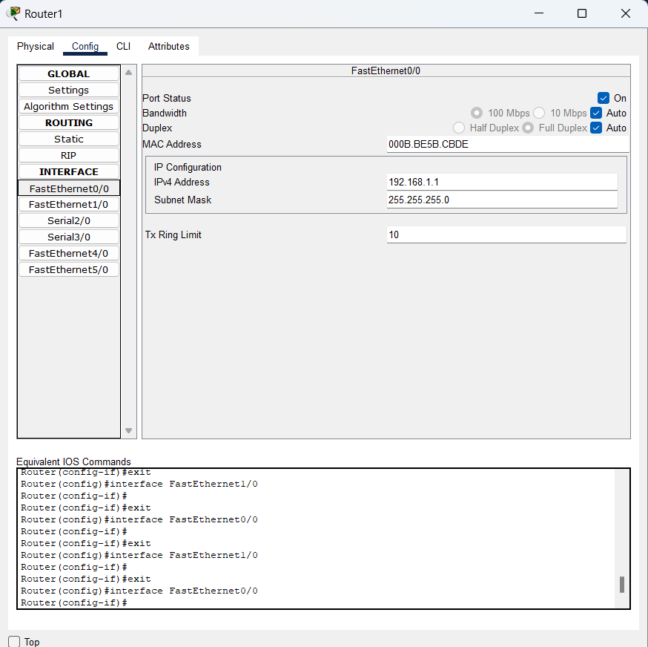 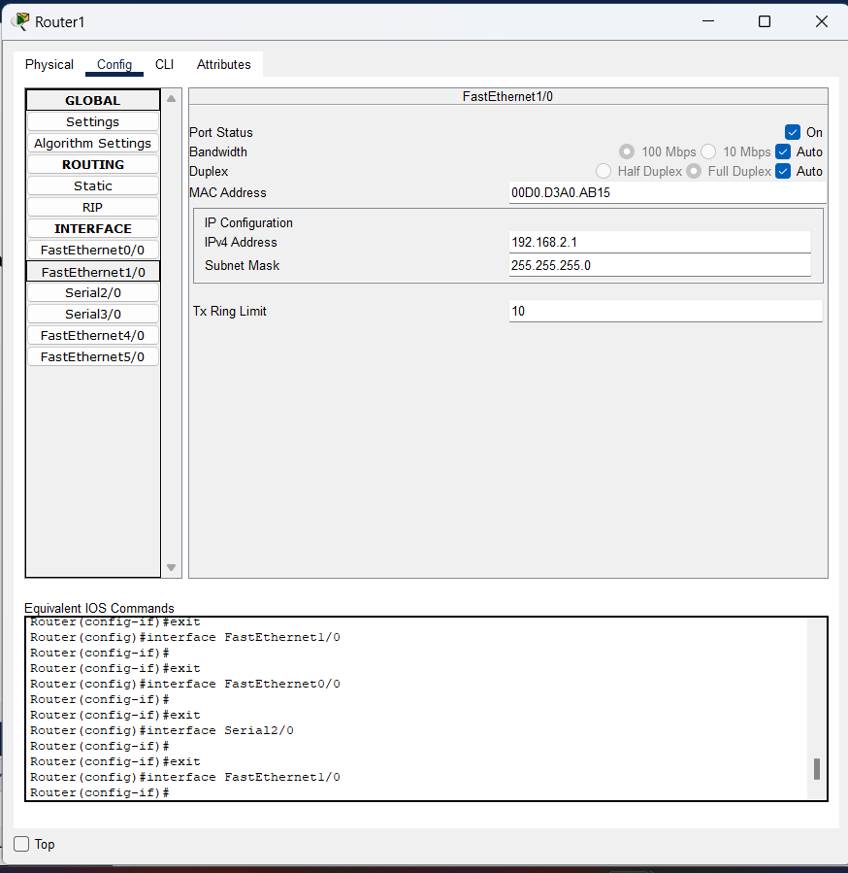

**Steps:**

1. ***Launch Cisco Packet Tracer:*** Open the Cisco Packet Tracer application on your computer.
2. ***Create Network Topology:*** Start a new project by selecting "Empty Physical Workspace". Then, drag and drop the devices you want to connect onto the workspace. You'll need at least two devices (e.g., PCs or switches) and a router.
3. ***Add a Router:*** Drag and drop a router from the "Routers" section onto the workspace.
4. ***Connect Devices to the Router:*** Use appropriate cables (usually straight-through copper cables) to connect the devices to the router. For example, connect PCs or switches to the router's Ethernet ports.
5. ***Assign IP Addresses (Optional):*** Double-click on each device to open its configuration window. Navigate to the "Desktop" tab and select "IP Configuration". Assign IP addresses to each device in the same subnet. If you're using a router, assign IP addresses to its interfaces as well.
6. ***Verify Connectivity:*** Open the command prompt or terminal on each device and use the ping command followed by the IP address of another device to verify connectivity. For example, from a PC connected to one interface of the router, ping a PC connected to another interface of the router.
7. ***Test Communication:*** Once connectivity is verified, test communication between devices by exchanging data or accessing shared resources.